Clock Divider

Introduction: -
A clock divider is a circuit that takes an input signal of a frequency fin and generates an output signal of a frequency fout, where
fout = fin / n and ''n'' is an integer

Block Interface

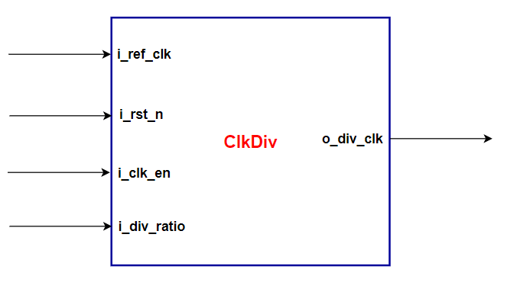

Ports Description

Width | Description | Signal Name
1 | Reference Frequency | I_ref_clk
1 | Active Low Asynchronous Reset | I_rst_n
1 | Clock Divider Block Enable | I_clk_en
1 | The divided ratio (integer value) | I_div_ratio

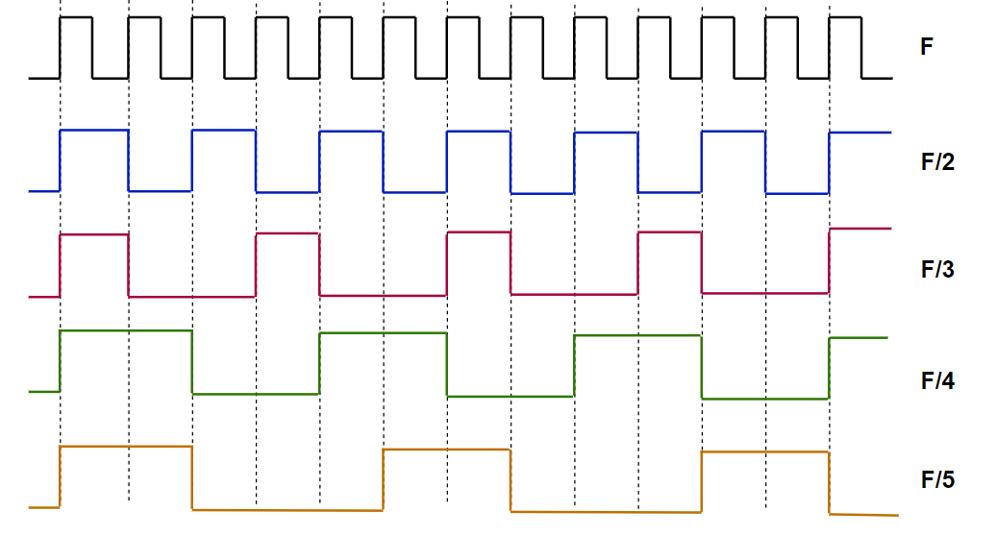
Waveforms

Requirements: -

- Write a Verilog Code to capture the above specifications
- Write a testbench to test generation of different frequencies of both odd and even divided ratio of the reference frequency

